Birla Institute of Technology & Science, Pilani Work Integrated Learning Program
2024-2025

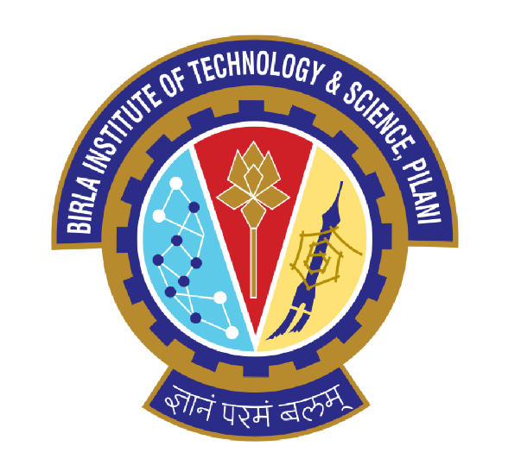

Submitted by:
Name: Mukund Vishwas Chavan
Course: Advanced Computer Networks
Student ID: 01011

Introduction

This assignment focuses on implementing different network topologies using Cisco Packet Tracer. Each task demonstrates fundamental networking concepts such as IP addressing, subnetting, LAN connectivity, and router configuration. The objective is to design, configure, and verify network communication between multiple hosts under various scenarios.
The assignment includes the following questions:
- Question 16(a): Simple LAN with 3 PCs connected via a switch, verifying connectivity and subnet isolation.
- Question 16(b): Two PCs on different networks connected via a router, configuring interfaces and static routing, verifying inter-network communication.
- Question 16(c): Star topology using switches and a router, verifying connectivity and IP configuration.

Tool Overview – Cisco Packet Tracer
Cisco Packet Tracer is an interactive network simulation software created by Cisco Systems. It enables users to design, build, and troubleshoot different types of computer networks without requiring real hardware. The software offers a virtual environment where network devices such as routers, switches, and end devices can be configured and interconnected to simulate real-world networking scenarios. In this assignment, Cisco Packet Tracer (Guest Mode) has been used to create and verify Local Area Network (LAN) and inter-network communication setups for Questions 16(a), 16(b), and 16(c). The tool provides real-time visual feedback, CLI access for routers and switches, and diagnostic utilities like ping and tracert for network testing.

Question 16(a): Simple LAN with 3 PCs and a Switch

Objective:
To create a simple LAN with three computers connected through a switch, assign static IP addresses, and verify communication using the ping command.

Step 1: Open Cisco Packet Tracer
Launch Cisco Packet Tracer and create a new blank workspace.

Step 2: Add Devices

Add the following devices to the workspace:
3 PCs: PC-0, PC-1, PC-2
1 Switch: Cisco 2960

Step 3: Connect Devices
Use Copper Straight-Through cables for all connections:
PC-0 → Switch Fa0/1
PC-1 → Switch Fa0/2
PC-2 → Switch Fa0/3

Screenshot: Connections established

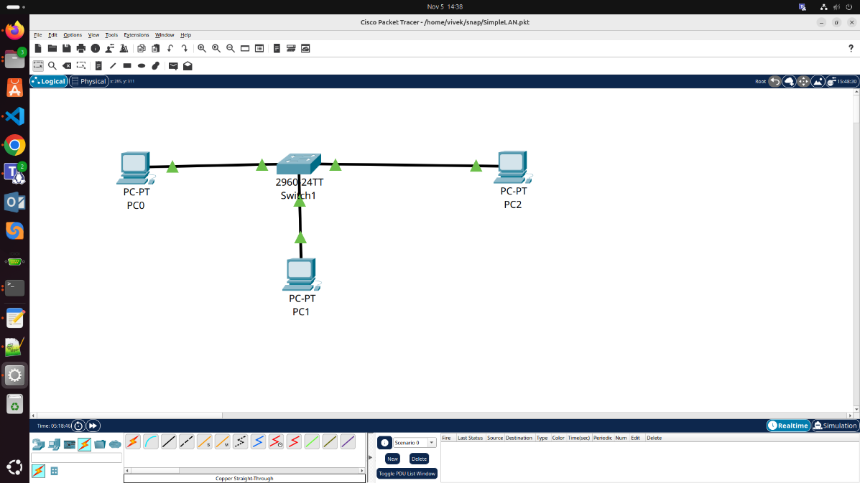

All PCs connected using copper straight-through cables.
Step 4: Assign IP Addresses
Assign static IP addresses as shown below:
Device | IP Address | Subnet Mask | Default Gateway
PC-0 | 192.168.1.2 | 255.255.255.0 | –
PC-1 | 192.168.1.3 | 255.255.255.0 | –
PC-2 | 192.168.1.4 | 255.255.255.0 | –

Screenshot: Static IP addresses assigned to all PCs.
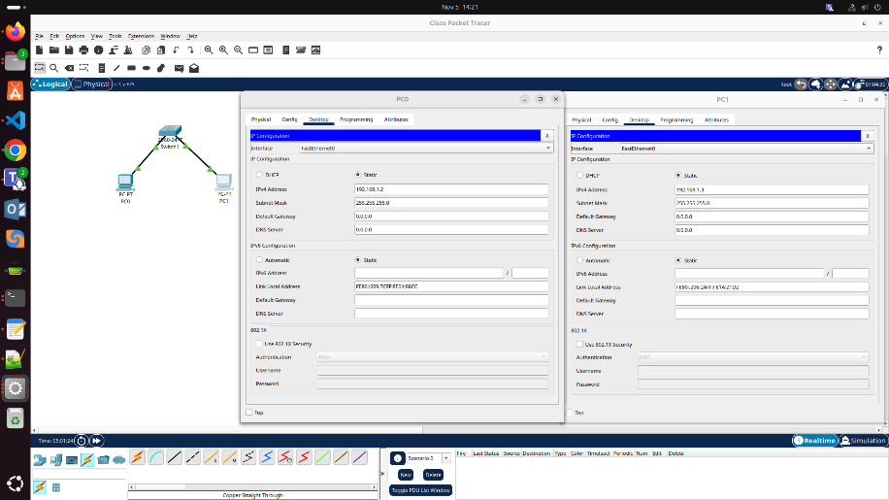
Step 5: Test Connectivity
From PC-0, open Command Prompt and execute:
ping 192.168.1.3
ping 192.168.1.4

Screenshot: Successful ping between all PCs.
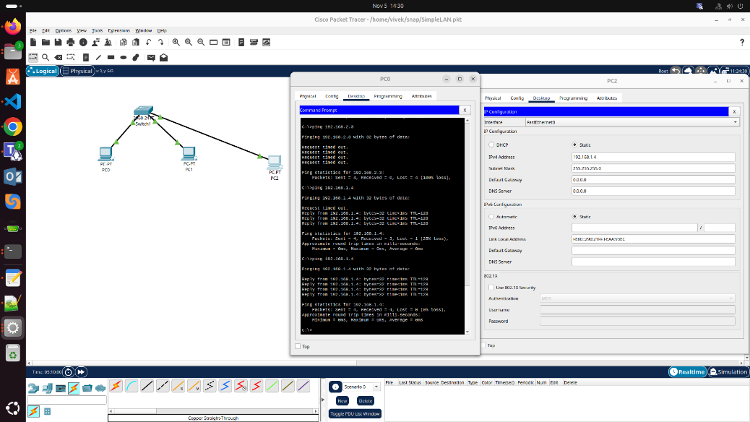
Step 6: Change Subnet to Test Isolation
Change PC-2’s IP to 192.168.2.4 with subnet mask 255.255.255.0 and test connectivity again. The ping should fail as it’s on a different subnet.

Screenshot: Ping fails when PC-2 is on a different subnet.
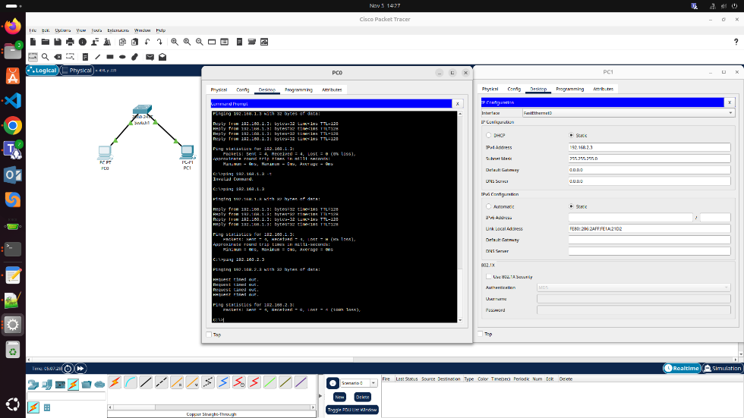

Question 16(b): Two PCs on Different Networks Using ROUTER

Objective:
To configure a router to connect two separate LANs and test successful inter-network communication.
Step 1: Add Devices
1 Router (Cisco 2911)
2 Switches
2 PCs (PC-1 and PC-2)

Screenshot: Topology layout for inter-network communication.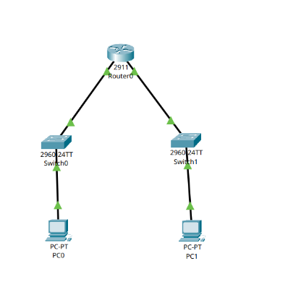

Step 2: Connect Devices
Use Copper Straight-Through cables to connect:
PC-1 → Switch0 Fa0/1
Switch0 → Router G0/0
PC-2 → Switch1 Fa0/1
Switch1 → Router G0/1

Step 3: Assign IP Addresses
Device | Interface | IP Address | Subnet Mask | Default Gateway
PC-1 | NIC | 192.168.1.2 | 255.255.255.0 | 192.168.1.1
Router | G0/0 | 192.168.1.1 | 255.255.255.0 | –
Router | G0/1 | 192.168.2.1 | 255.255.255.0 | –
PC-2 | NIC | 192.168.2.2 | 255.255.255.0 | 192.168.2.1

Step 4: Configure Router Interfaces (CLI)
enable
configure terminal
interface gigabitEthernet0/0
ip address 192.168.1.1 255.255.255.0
no shutdown
exit
interface gigabitEthernet0/1
ip address 192.168.2.1 255.255.255.0
no shutdown
exit
end
write

Screenshot: Router configured to enable inter-network routing.
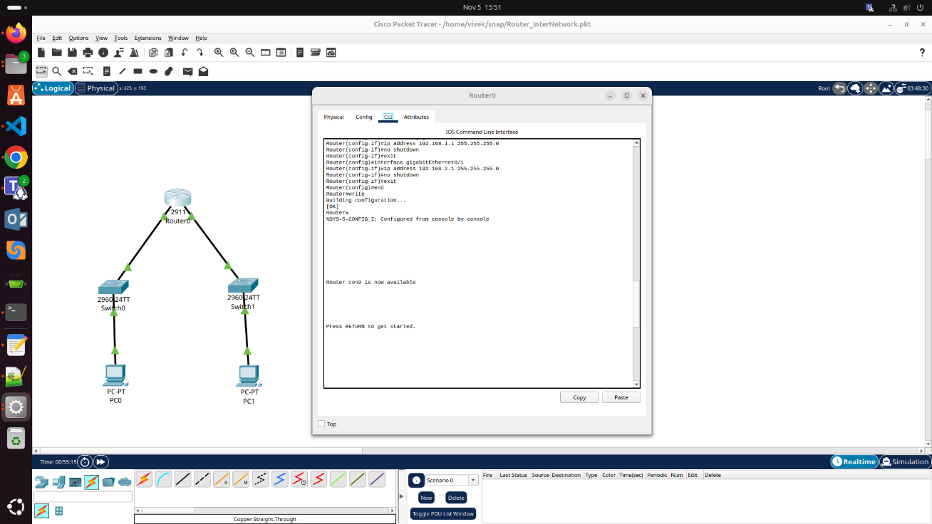

Step 5: Configure Gateways and Test
- Set default gateway on PC-1: 192.168.1.1
- Set default gateway on PC-2: 192.168.2.1
Ping PC-2 from PC-1 using:
ping 192.168.2.2
Successful reply confirms router functionality.

Screenshot: Ping success confirms connectivity via router.
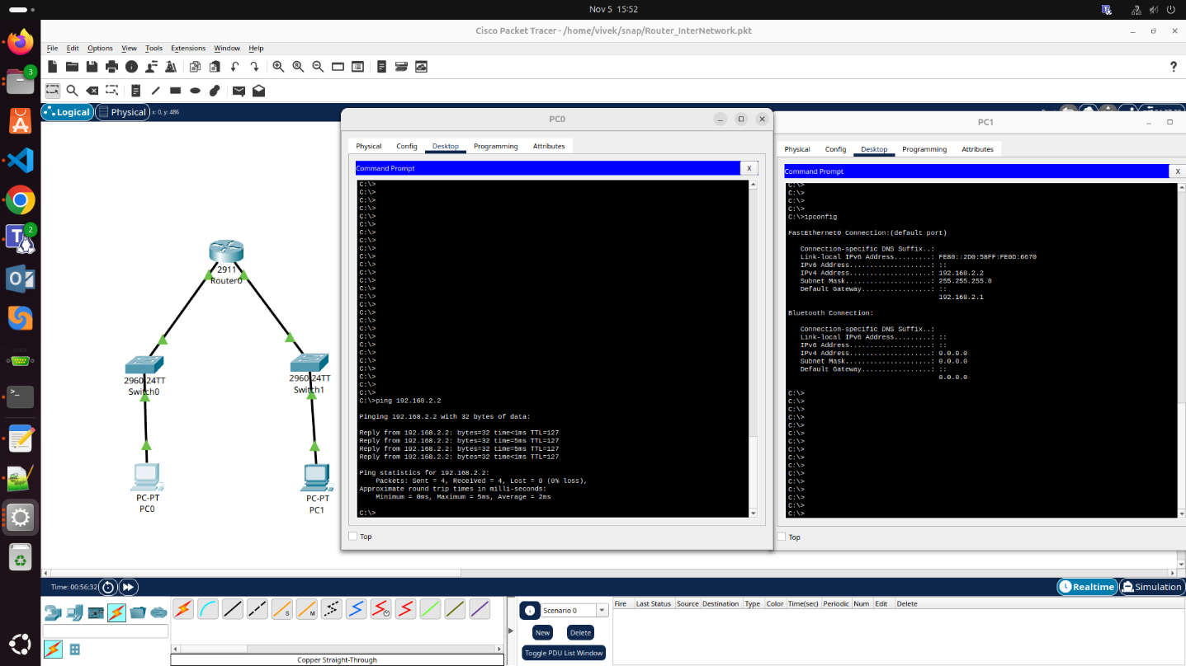

Question 16(c): Star Topology Using Switches and Router

Objective:
To design and test a star topology where all devices are connected through a central switch and communicate through a router.

Step 1: Create Topology
Add the following devices:
1 Central Switch (2960)
3 PCs (PC-1, PC-2, PC-3)
1 Router

Step 2: Connect Devices
Use Copper Straight-Through cables:
PC-1 → Switch Fa0/1
PC-2 → Switch Fa0/2
PC-3 → Switch Fa0/3
Router → Switch Fa0/4

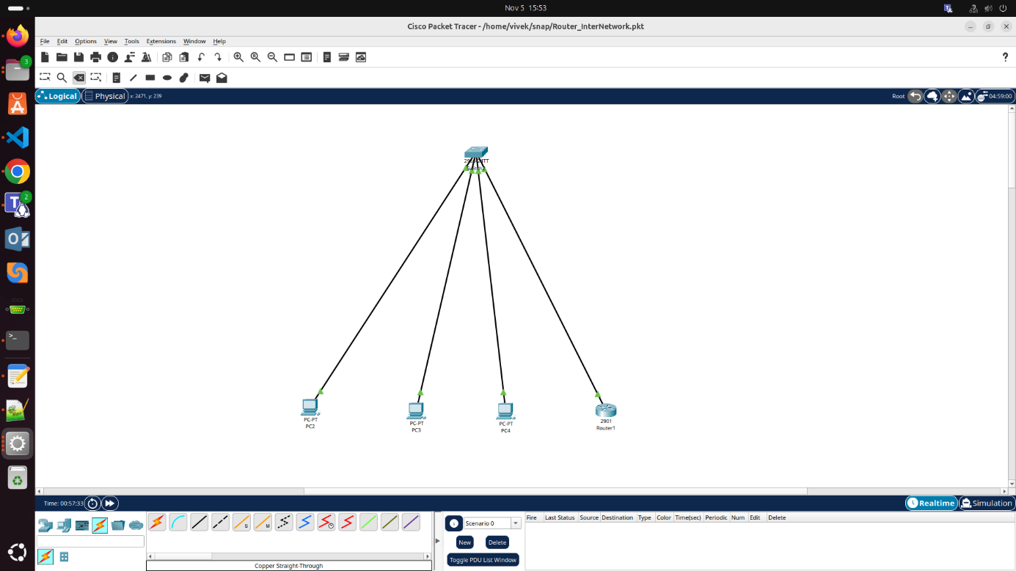

Step 3: Assign IP Addresses
Device | Interface | IP Address | Subnet Mask
PC-1 | NIC | 192.168.10.2 | 255.255.255.0
PC-2 | NIC | 192.168.10.3 | 255.255.255.0
PC-3 | NIC | 192.168.10.4 | 255.255.255.0
Router | G0/0 | 192.168.10.1 | 255.255.255.0

Step 4: Configure Router Interface (CLI)
enable
configure terminal
interface gigabitEthernet0/0
ip address 192.168.10.1 255.255.255.0
no shutdown
exit
end
write

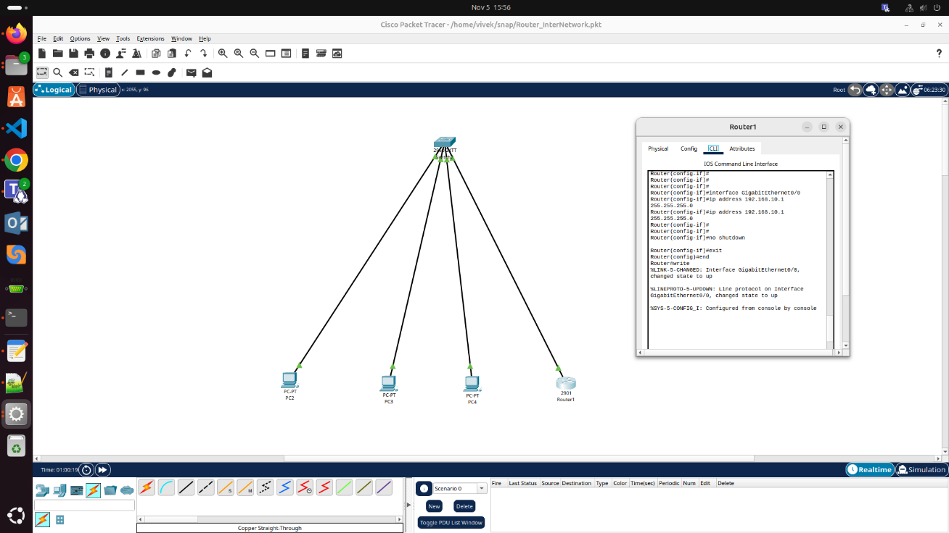

Step 5: Verify and Test Connectivity
From PC-1:
ping 192.168.10.3
ping 192.168.10.1
Both pings should be successful, confirming star topology functionality.

Screenshot: Successful communication between PCs and router in star topology.

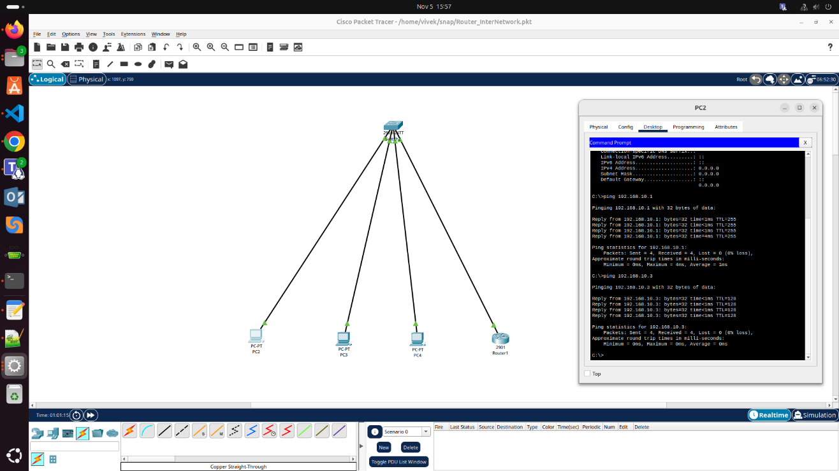

Implementation Environment
All network configurations were implemented in Cisco Packet Tracer v8.x (Guest Mode). Each topology was saved as a separate .pkt file. The testing was done using the built-in Command Prompt available in Packet Tracer to execute ping and tracert commands for verifying communication paths and device reachability.

Conclusion
All three network setups were successfully created, configured, and tested using Cisco Packet Tracer. The experiments demonstrated practical understanding of LAN communication, inter-network routing, and centralized topology design. Each configuration worked as expected, with accurate IP assignments, functional router interfaces, and verified device connectivity.
Cisco Packet Tracer proved to be an effective platform for hands-on networking practice and visualization of real-time data exchange across networks.

I have stored all 3 .pkt on GitHub following link:
https://github.com/mukundchavan251/BITS/tree/main/Sem3-2025/1-Advanced%20Computer%20Networks%20(S3-25_ESZG525%20)/Assingments

